AKSA Instrument Spec Database Administrator’s Guide

Overview 3
Opening the Application 3
Tools 5
Instrument Spec Audit Trail 5
Administration Audit Trail 8
Lookup Tables 10
Sorting records 10
Adding a new record 10
Editing a record 11
Deleting a record 11
Limiting the number of records returned 12
Finding a record 13
Lookup table form reference 15
Edit Classifications 15
Edit Control Valve Types 16
Edit Drawing List 17
Edit Drawing Types 18
Edit Equipment List 19
Edit Equipment Types 20
Edit Flow Meter Subtypes 21
Edit Flow Meter Types 22
Edit Fluid Phases 23
Edit Instrument Function Types 24
Edit Instrument Location List 25
Edit Instrument Manufacturers List 26
Edit Instrument Model List 27
Edit Line Types 28
Edit Lines 29
Edit Loops 31
Edit Loop Functions 32
Edit Loop Processes 33
Edit Loop Types 34
Edit Pipe Classes 35
Edit Pipe Materials 36
Edit Plant Areas 37
Edit Process Functions 38
Edit Units of Measure 39
Edit Unit of Measure Types 40
Security 41
User Access 41
Sorting records 42
Adding a new record 43
Editing a record 43
Deleting a record 43
Role Members 44
Adding a new record 44
Editing a record 44
Deleting a record 45

Overview
The AKSA Instrument Spec Database provides a convenient, web-based interface for viewing, printing and maintaining process instrumentation specifications. This document describes the procedures for administering the application by utilizing the audit trail, updating the lookup tables and maintaining user access.

Opening the Application
A link to the Instrument Spec Database is located on the AKSA intranet home page under the “Maintenance” header (Figure 1).

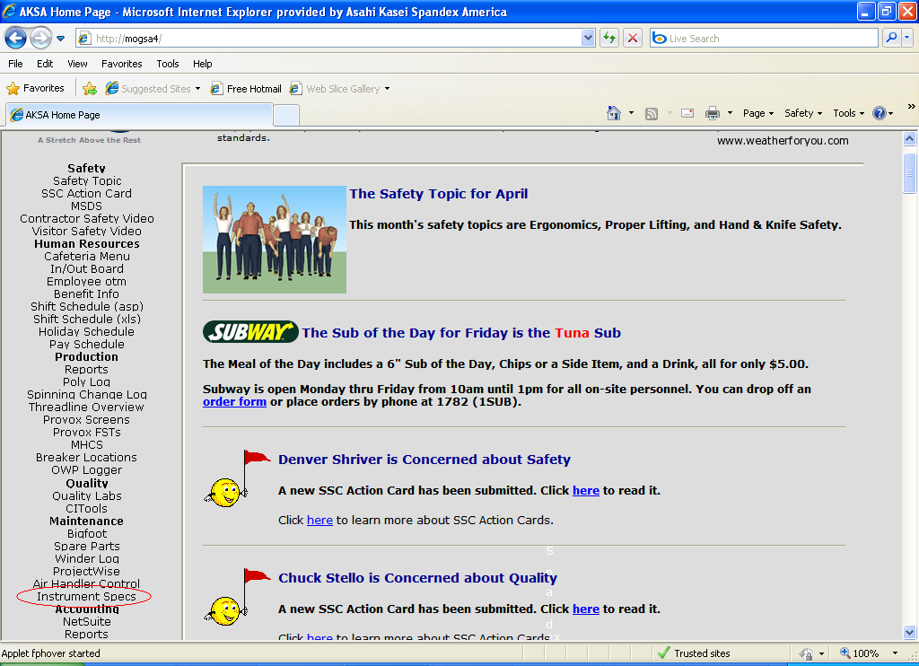
Figure 1

Clicking this link will display the application main menu. The administration main menu is accessed by clicking the “Administration” button (Figure 2).

The Instrument Spec Database Administration main menu (Figure 3) is divided into three categories for maintaining the application operation:

- Tools – Forms that enable the administrator to query the database in useful ways (e.g. the audit trail).
- Lookup Tables – Forms for updating the database tables used in dropdown lists for data entry.
- Security – Forms for maintaining user access to the application.

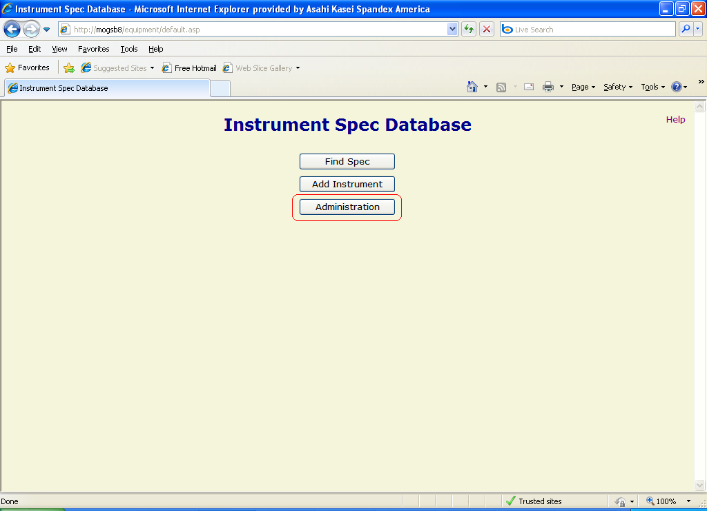
Figure 2

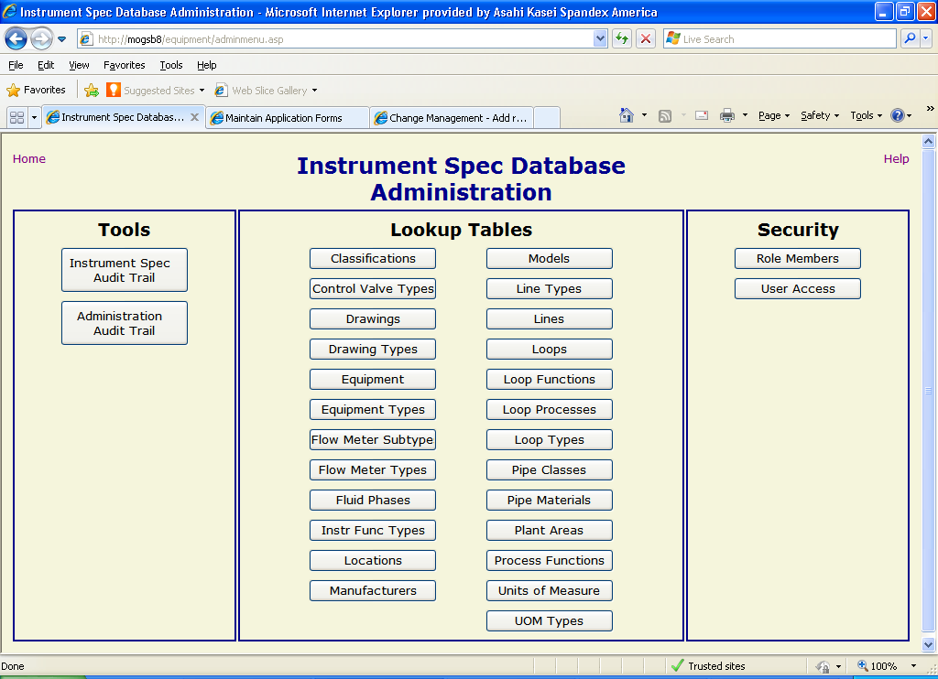
Figure 3

Tools
This category contains useful methods of tracking changes and looking at the data in the Instrument Spec database.

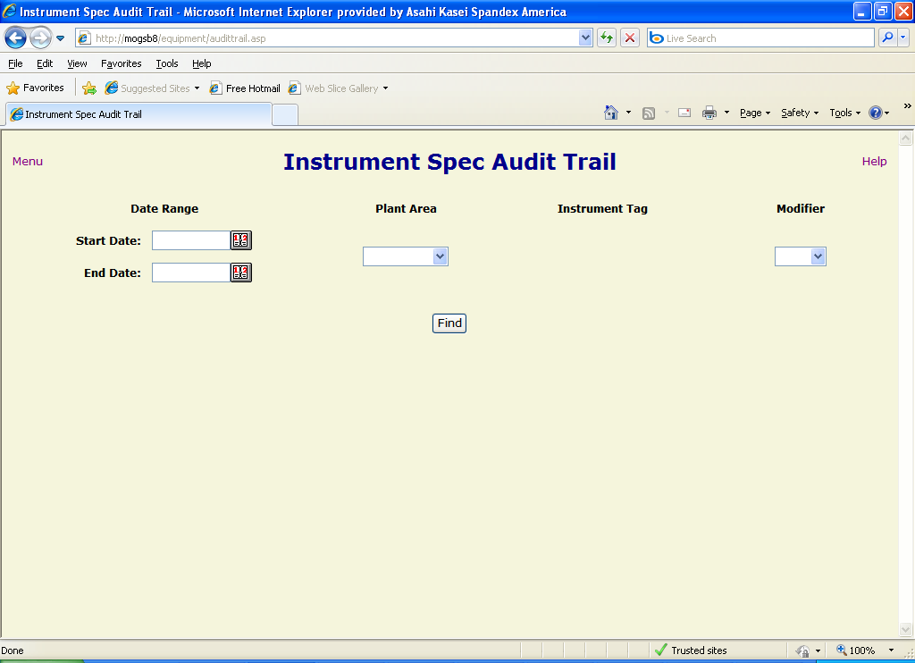
Figure 4

Instrument Spec Audit Trail
The Instrument Spec Audit Trail (Figure 4Error: Reference source not found) is a tool for searching and viewing modifications made to specification-related data in the database. The user can select filter criteria to narrow the search results:

- Date Range – A start and end date to limit the time frame in which the change occurred. If the start date is omitted, the search includes the earliest data in the audit trail table up to the end date. If the end date is omitted, the results contain data from the start date to the most recent entry in the table. If both are left blank, then the entire table is searched.
- Plant Area – The user can select a plant process area from the dropdown list to return only changes to specs for instruments assigned to that area. When a plant area is selected, the page refreshes to provide a dropdown list of instruments assigned to that area (Figure 5).
- Instrument Tag – Once a plant area has been selected, the user can select an instrument tag number for which to search. This will limit the results to only include changes to that instrument spec.
- Modifier – The username of the individual that made the change. Selecting a user from the dropdown list will limit the results accordingly.

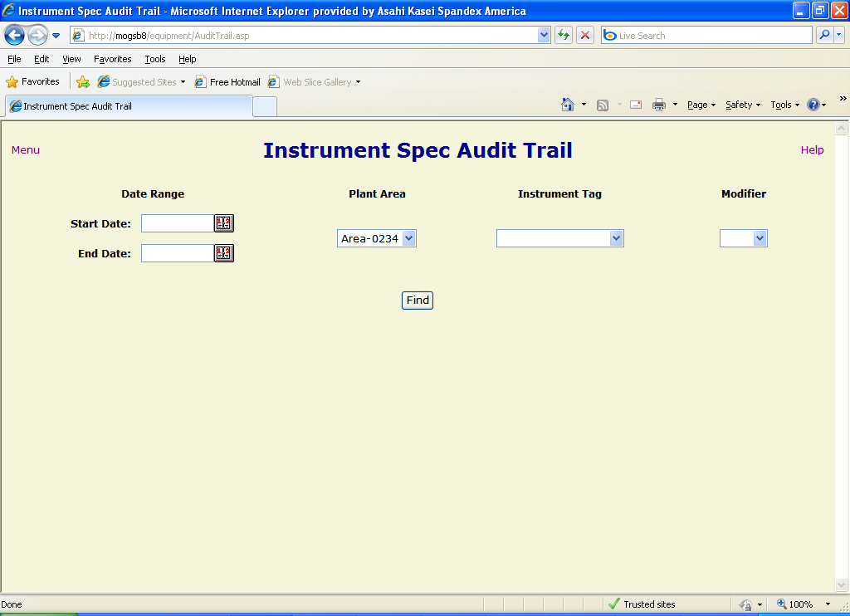
Figure 5

Once the filter criteria have been entered (NOTE: at least one criterion must be chosen), the user clicks on the “Find” button to return the matching results (Figure 6). The records are shown with the following fields:

- Timestamp – The date and time that the modification occurred.
- Modifier – The username of the individual that made the change.
- Instrument – The tag number of the instrument to whose spec the change was made.
- Table.Field – The names of the database table and field to which the change occurred. In many cases, the names are descriptive and will readily tell the user what parameter was changed. In other cases, the names are cryptic and will need to be cross-referenced with a label in the spec_formats table to provide meaningful information.
- Old Value – The value that the field contained before the modification was made.
- New Value – The value to which the field was changed.
- Change Type – The type of data modification (“delete”, “insert” or “update”) that the change involved.

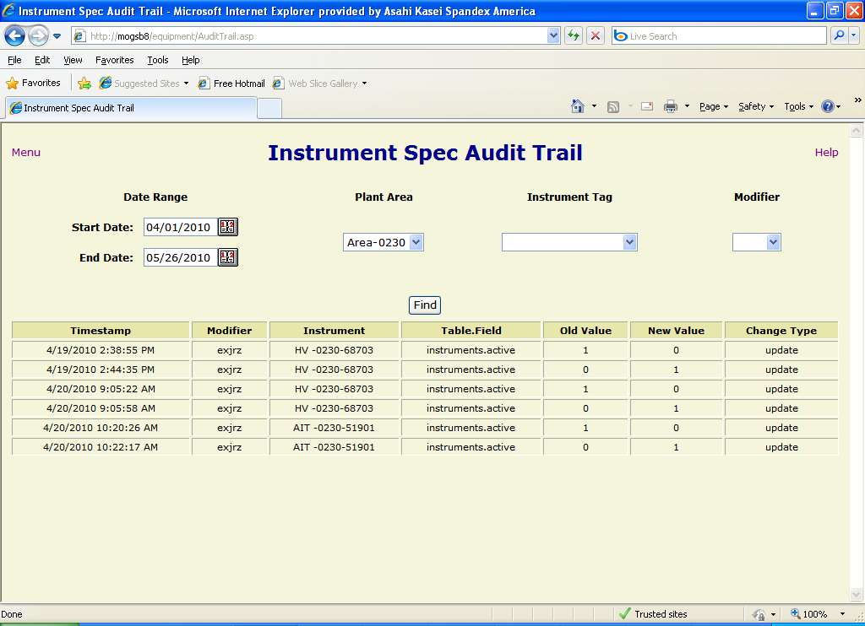
Figure 6

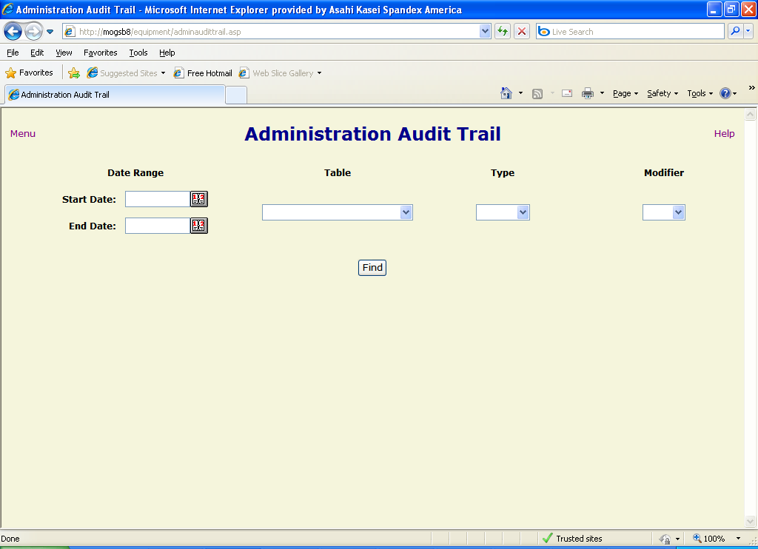
Figure 7

Administration Audit Trail
The Administration Audit Trail (Figure 7) allows users to search and view changes made to the administrative (i.e. “lookup”) tables in the database. The user can use the following filter criteria to limit the search results:

- Date Range – A start and end date to limit the time frame in which the change occurred. If the start date is omitted, the search includes the earliest data in the audit trail table up to the end date. If the end date is omitted, the results contain data from the start date to the most recent entry in the table. If both are left blank, then the entire table is searched.
- Table – Data in a relational database is stored in tables. The user can select from a list of administrative tables to specify the type of data being searched for. In most cases, the names of the tables are descriptive of the category of data contained. Choosing a table from the list will only return modifications to data in that particular table.
- Type – The type of change that was made to the data (“delete”, “insert” or “update”). Selecting from this list will limit the results to only the specified type of change.
- Modifier – The username of the individual that made the change. Selecting a user from the dropdown list will limit the results accordingly.

Once the user has selected the filter criteria (NOTE: at least one filter must be entered), the user clicks on the “Find” button to return the matching results (Figure 8). The records are shown with the following fields:

- Timestamp – The date and time that the modification occurred.
- Modifier – The username of the individual that made the change.
- Table ID – The primary key (unique identifier) of the record in the table being modified.
- Table.Field – The names of the database table and field to which the change occurred. In most cases, the names are descriptive and will readily tell the user what parameter was changed.
- Old Value – The value that the field contained before the modification was made.
- New Value – The value to which the field was changed.
- Change Type – The type of data modification (“delete”, “insert” or “update”) that the change involved.

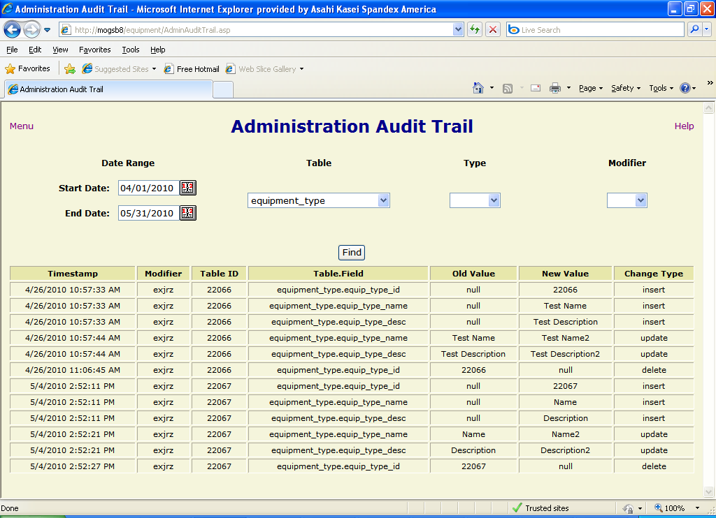
Figure 8

Lookup Tables
The Lookup Tables section provides links to forms that allow an administrator to view and modify the tables that contain the data utilized in dropdown lists on instrument specs and other forms. All of the forms have the same functionality for sorting, inserting, updating and deleting table records, but some have additional options to limit the display of large numbers of records. NOTE: Some of the options described below may not be accessible to a user based on that user’s permissions.

Sorting records
Each column header for a displayed table has links to allow the user to sort the table records based on the data contained in that column. Clicking on the icon sorts the records in descending order (e.g. 5, 4, 3, 2, 1), while clicking on the icon sorts the records in ascending order (e.g. 1, 2, 3, 4, 5).

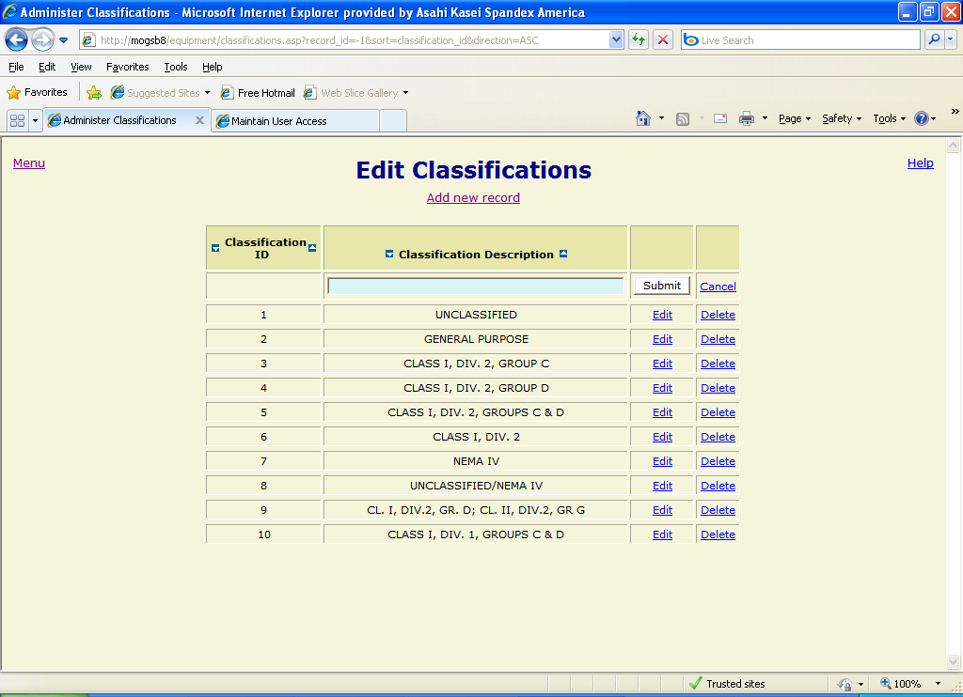
Figure 9

Adding a new record
To insert a new record into the table associated with a lookup table form, click on the “Add new record” link below the page title. A blank record will be opened in the first row of the table with text boxes or dropdown lists displayed for modifiable fields (Figure 9). Enter the desired data in the fields and click the “Submit” button to insert the record. The page will refresh with the new record in its appropriate position based on the specified sort order. To cancel the insertion of a record before submitting, click the “Cancel” link or use your browser’s “back” button.

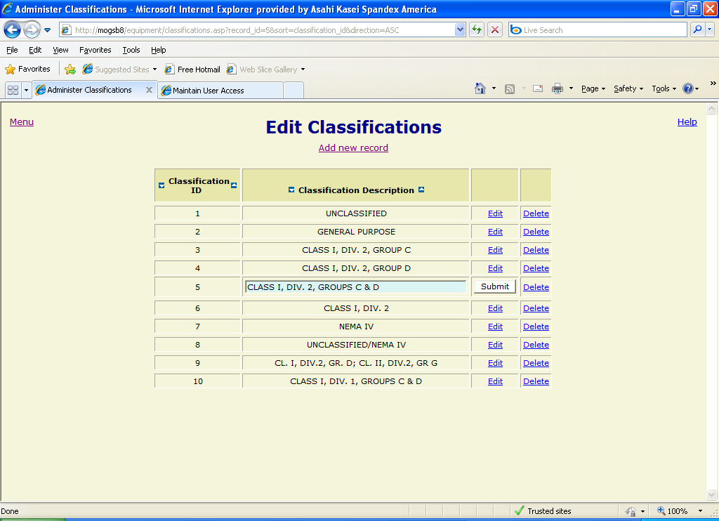
Figure 10

Editing a record
To edit an existing record, click on the “Edit” link to the right of the record to be modified. The record will be displayed with modifiable fields as text boxes or dropdown lists (Figure 10). After changing the field values as desired, click the “Submit” button to the right of the record to update the database. To cancel the update before submitting, use the “back” button on your browser to return to the previous screen.

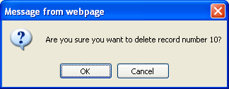
Figure 11

Deleting a record
To delete an existing record, click the “Delete” link to the right of the record to be deleted. A confirmation message (Figure 11) will be displayed. Click the “OK” button to complete the deletion or the “Cancel” button to stop it.

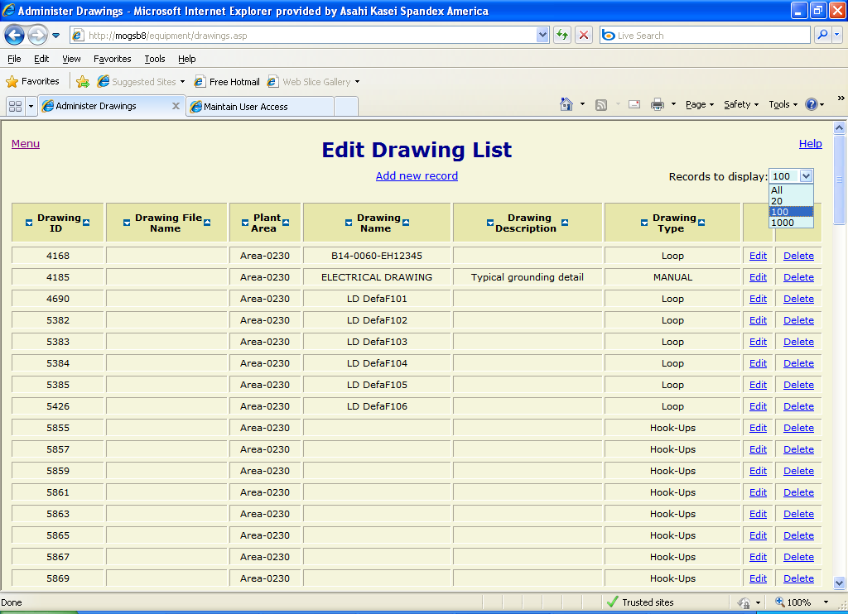
Figure 12

Limiting the number of records returned
Since some of the tables in the instrument spec database contain a large number of records, it is sometimes necessary to limit the number of records returned to improve application performance. Forms for these tables offer such an option. By opening the “Records to display” dropdown list in the upper right-hand corner of the form, the user can select the number of items to return from a list of options (Figure 12). When the user clicks on the desired option, the page is redrawn to display the corresponding number of records. If the number selected is large, the page update may take considerable time.

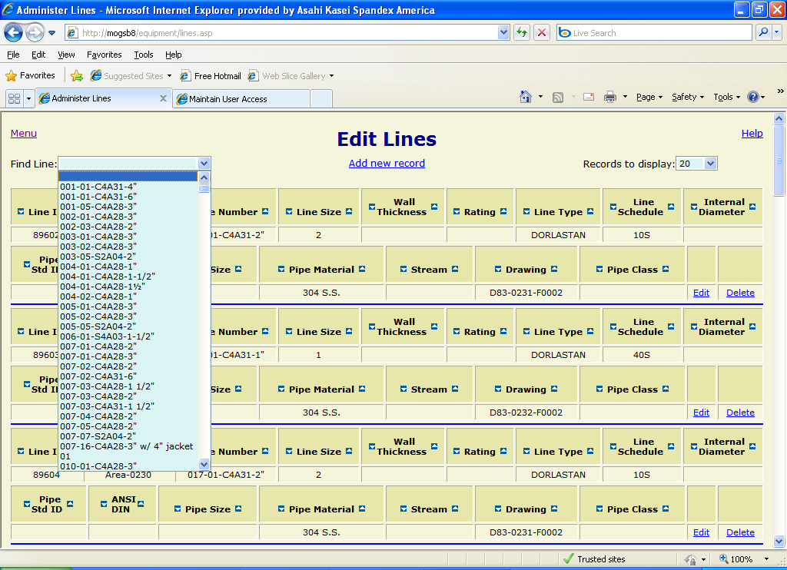
Figure 13

Finding a record
For some tables, the amount of data is so large that it is difficult to wade through all of the records to find the desired one. For this case, the user may select the appropriate item from a dropdown list in the upper left-hand corner of the page (Figure 13). Clicking on a selection in the list will cause the form to reload and display only the selected record. In some cases, the dropdown list itself may be filtered by first selecting a plant area before the dropdown list of record items is displayed (Figure 14).

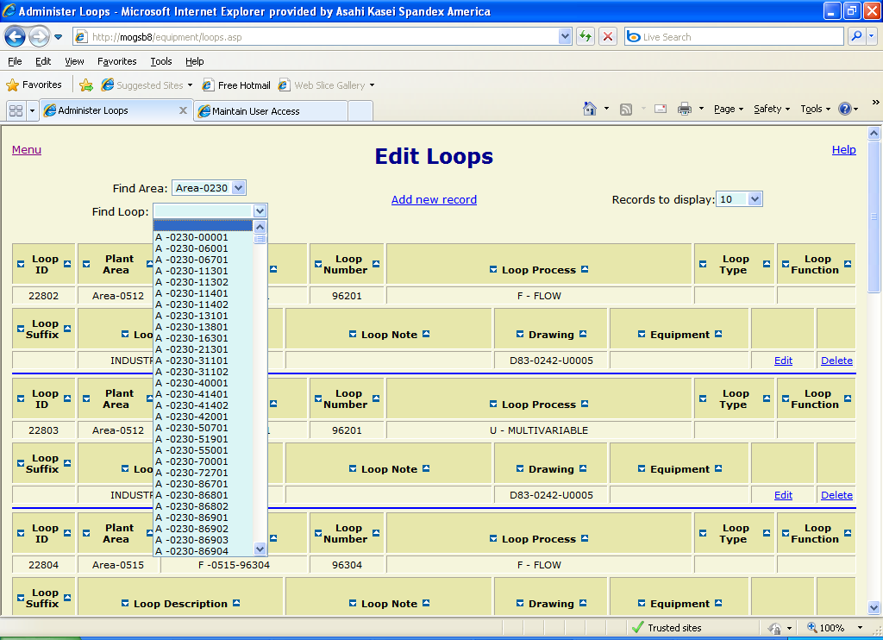
Figure 14

Lookup table form reference

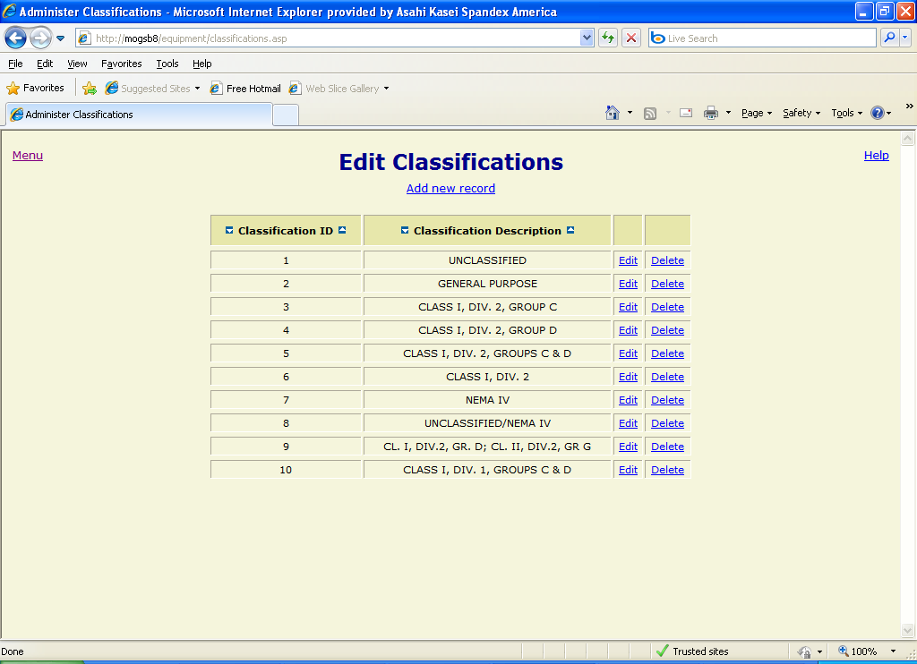
Figure 15

Edit Classifications
Updates the classification table. This data is used on instrument spec forms to specify the area classification for the instrument (e.g. “Class I, Div. 2”). The table consists of the following fields:
- classification_id – Unique identifier, automatically assigned.
- classification_desc – Description of the classification (required, must be unique).

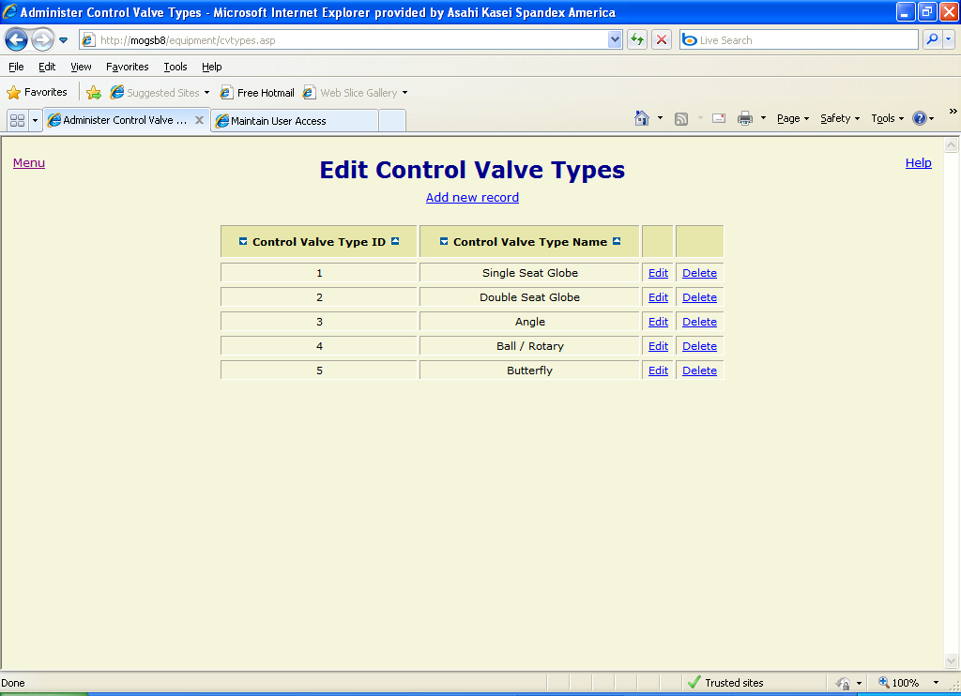
Figure 16

Edit Control Valve Types
Updates the control_valve_types table. This data is used on some instrument spec forms to specify the control valve form (e.g. “Butterfly”). The table consists of the following fields:
- cv_type_id – Unique identifier, automatically assigned.
- cv_type_name – The name of the control valve type (required, must be unique).

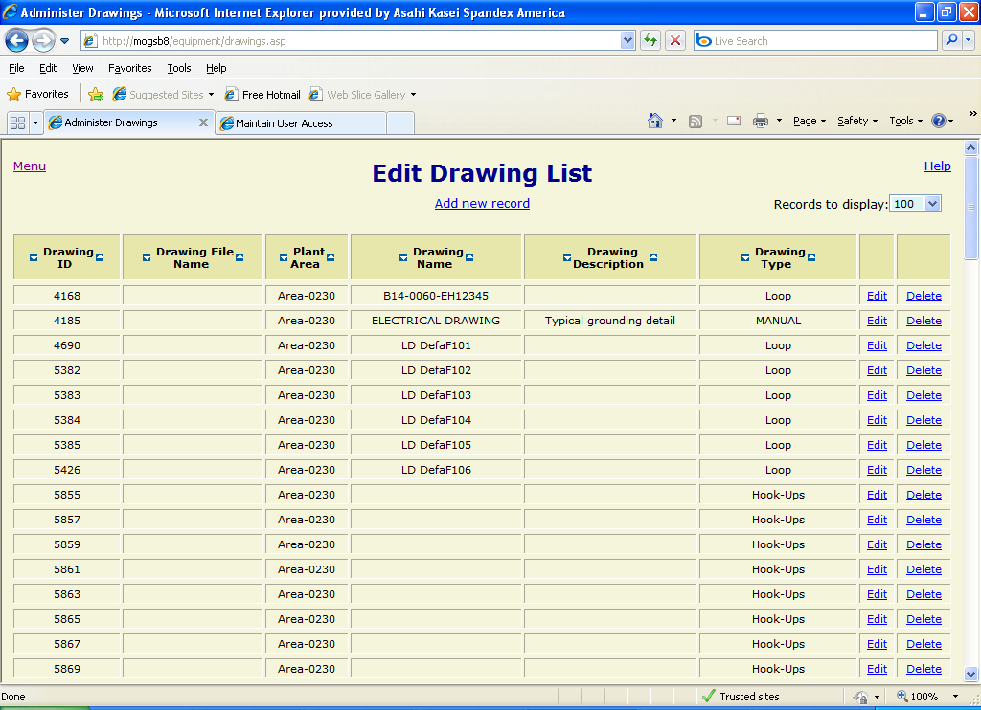
Figure 17

Edit Drawing List
Updates the drawings table. This data is used on instrument spec forms, as well as several administrative forms to specify the drawing associated with an instrument, line or loop. The table consists of the following fields:
- dwg_id – Unique identifier, automatically assigned.
- dwg_file_name – The physical file name of the drawing.
- plant_area_id – The plant area to which the drawing applies, id number from the plant_areas table.
- dwg_name – The name of the drawing.
- dwg_desc – Description of the drawing.
- dwg_type_id – The drawing type (e.g. “P&ID”), id number from the drawing_types table.

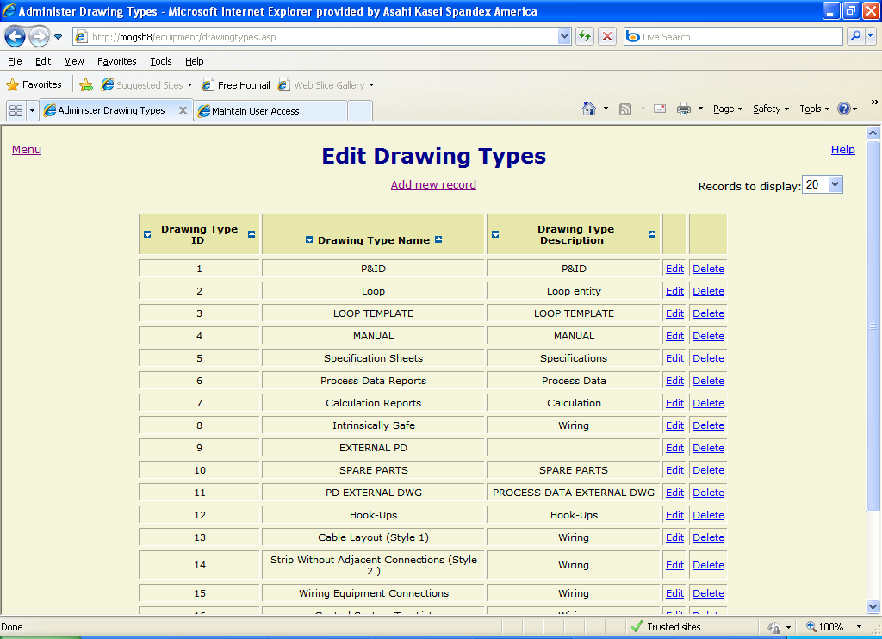
Figure 18

Edit Drawing Types
Updates the drawing_types table. This data is used on the “Drawings” administrative form to specify the category of drawing (e.g. “P&ID”). The table consists of the following fields:
- dwg_type_id – Unique identifier, automatically assigned.
- dwg_type_name – The name of the drawing type (required, must be unique).
- dwg_type_desc – Description of the drawing type.

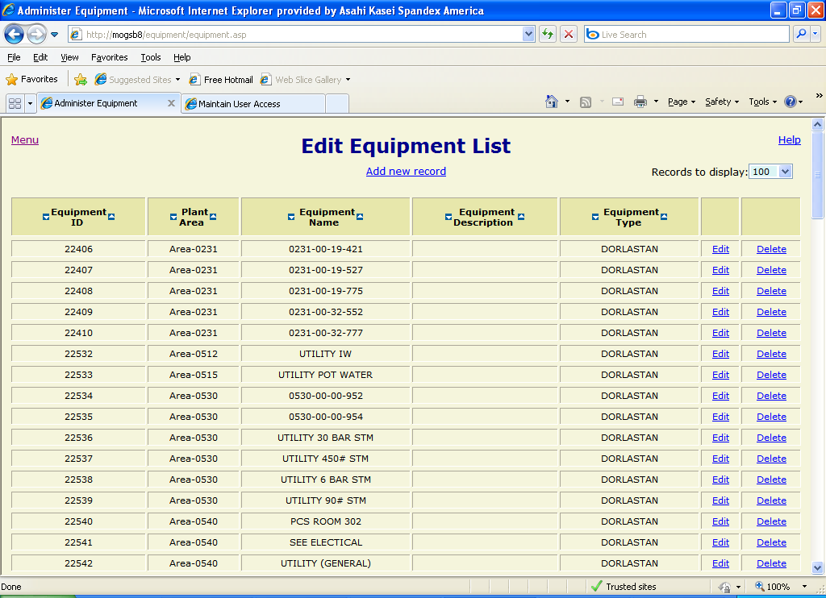
Figure 19

Edit Equipment List
Updates the equipment table. This data is used on instrument spec forms or when adding a new instrument to specify the piece of equipment to which the instrument is associated (e.g. “0231-00-19-421”). The table contains the following fields:
- equip_id – Unique identifier, automatically assigned.
- plant_area_id – Plant area to which the equipment is assigned, id number from plant_areas table.
- equip_name – Name of the piece of equipment (required, must be unique).
- equip_desc – Description of the piece of equipment.
- equip_type_id – Type of equipment, id number from equip_type_id table.

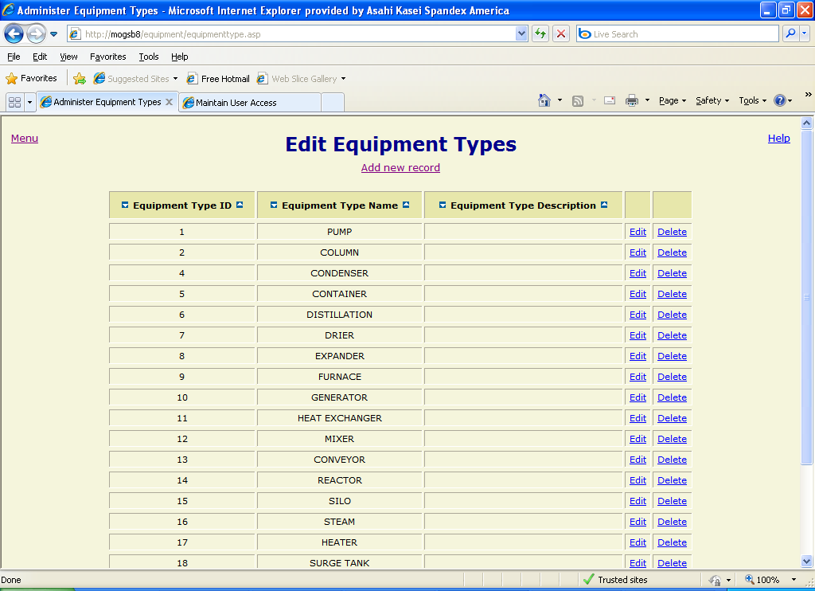
Figure 20

Edit Equipment Types
Updates the equipment_type table. This data is used on the “Equipment” administrative form to specify the type of the equipment. The table consists of the following fields:
- equip_type_id – Unique identifier, automatically assigned.
- equip_type_name – The name of the equipment type (required, must be unique).
- equip_type_desc – Description of the equipment type.

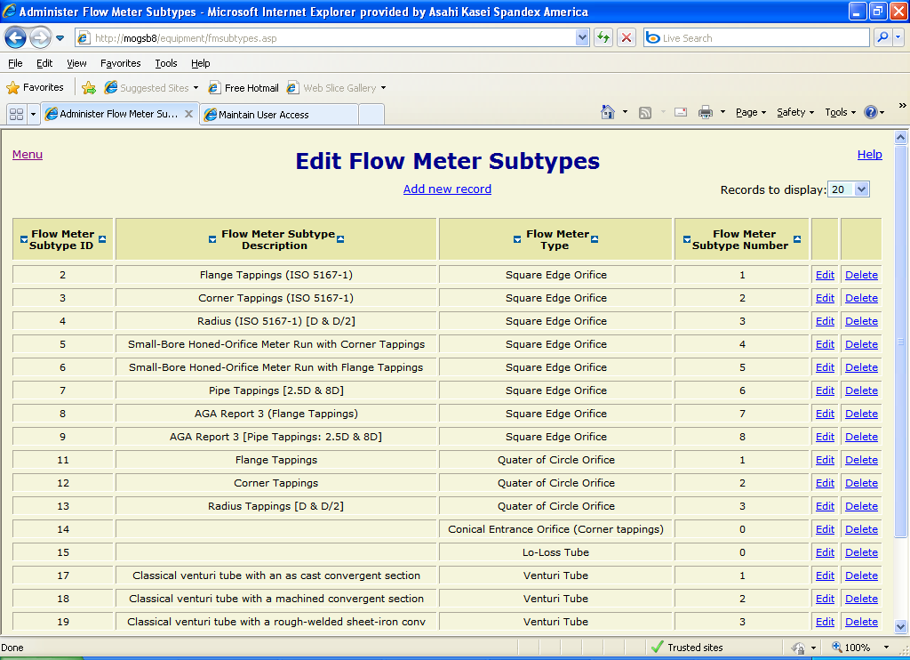
Figure 21

Edit Flow Meter Subtypes
Updates the flow_meter_subtypes table. This data is used on instrument spec forms to specify the subtype of flow meter. The table consists of the following fields:
- fm_subtype_id – Unique identifier, automatically assigned.
- fm_subtype_desc – Description of the flow meter subtype.
- fm_type_id – Flow meter type to which the subtype applies, id number from the flow_meter_types table.
- fm_subtype_number – Index number of the flow meter subtype within the flow meter type.

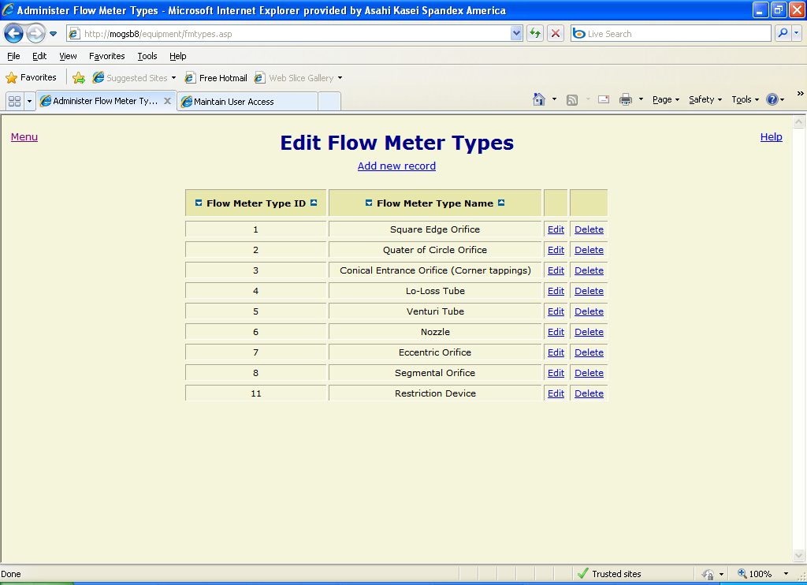
Figure 22

Edit Flow Meter Types
Updates the flow_meter_types table. This data is used on instrument spec forms to specify the type of the flow meter. The table consists of the following fields:
- fm_type_id – Unique identifier, automatically assigned.
- fm_type_name – The name of the flow meter type (required, must be unique).

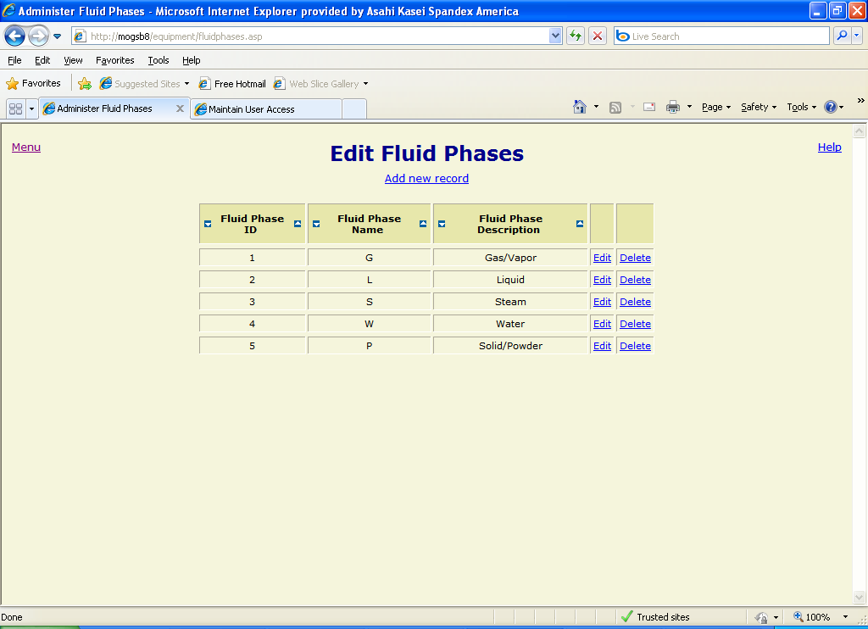
Figure 23

Edit Fluid Phases
Updates the fluid_phases table. This data is used on instrument spec forms to specify the fluid phase for the instrument specification. The table consists of the following fields:
- fluid_phase_id – Unique identifier, automatically assigned.
- fluid_phase_name – A single character name for the fluid phase (required, must be unique).
- fluid_phase_desc – Description of the fluid phase.

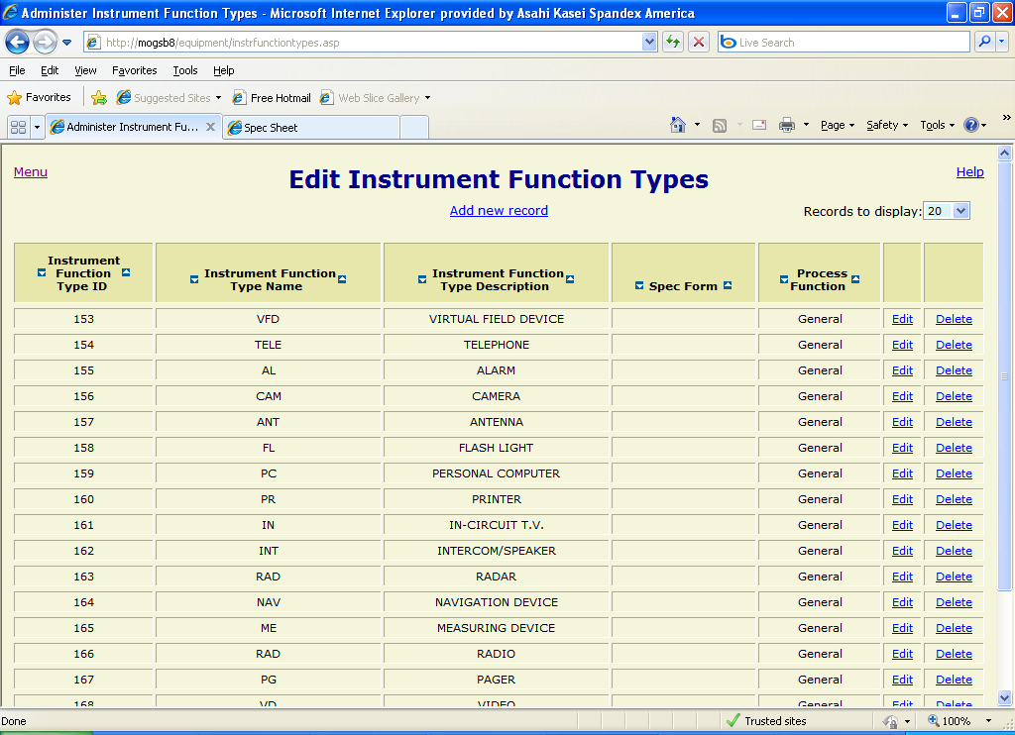
Figure 24

Edit Instrument Function Types
Updates the instrument_function_types table. This data is used when adding a new instrument specification or searching for an existing one. The table consists of the following fields:
- instr_func_type_id – Unique identifier, automatically assigned.
- instr_func_type_name – The name of the instrument function type (required).
- instr_func_type_desc – Description of the instrument function type.
- instr_func_type_spec_form_id – The spec form type to which instruments with this function type should default, id number from the spec_forms table.
- proc_func_id – The process function to which the instrument function type applies, id number from the process_functions table.

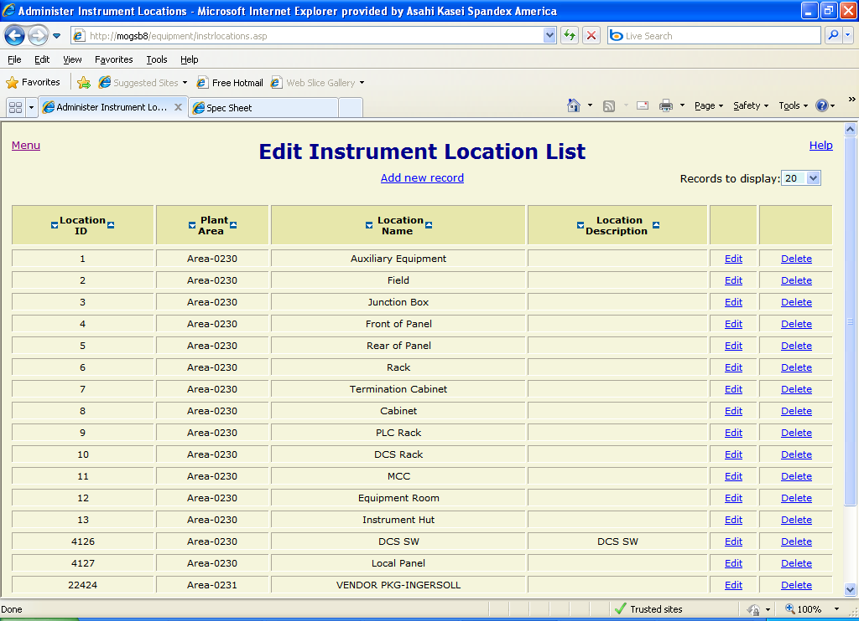
Figure 25

Edit Instrument Location List
Updates the instrument_locations table. This data is used on instrument spec forms to specify the physical location of the instrument. The table consists of the following fields:
- instr_location_id – Unique identifier, automatically assigned.
- plant_area_id – The plant area to which the location applies, id number from the plant_areas table.
- instr_location_name – The name of the instrument location (required, must be unique).
- instr_location_desc – Description of the instrument location.

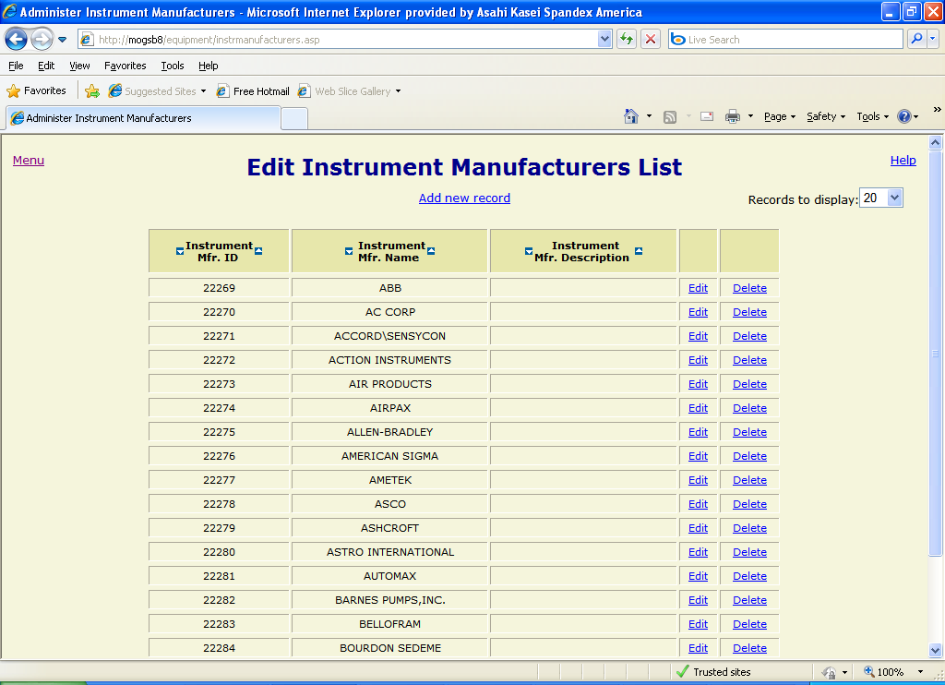
Figure 26

Edit Instrument Manufacturers List
Updates the instrument_manufacturers table. This data is used on instrument spec forms to specify the manufacturer of the instrument. Corresponding instrument models are automatically updated on the form when a specific manufacturer is selected. The table consists of the following fields:
- instr_mfr_id – Unique identifier, automatically assigned.
- instr_mfr_name – The name of the instrument manufacturer (required, must be unique).
- instr_mfr_desc – Description of the instrument manufacturer.

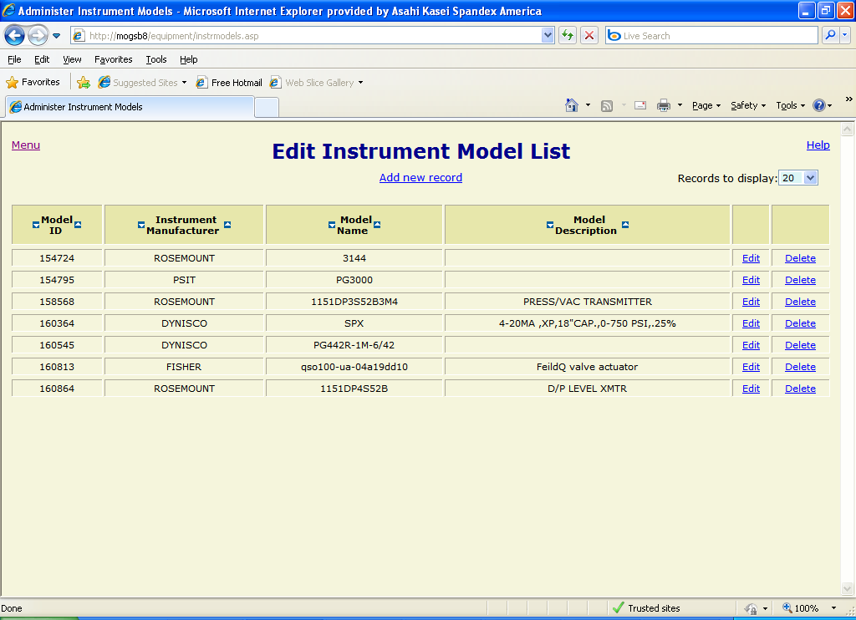
Figure 27

Edit Instrument Model List
Updates the instrument_models table. This data is used on instrument spec forms to specify the manufacturer model of the instrument. The table consists of the following fields:
- instr_mod_id – Unique identifier, automatically assigned.
- instr_mfr_id – The manufacturer to which the model applies, id number from the instrument_manufacturers table.
- instr_mod_name – The name of the instrument model (required).
- instr_mod_desc – Description of the instrument model.

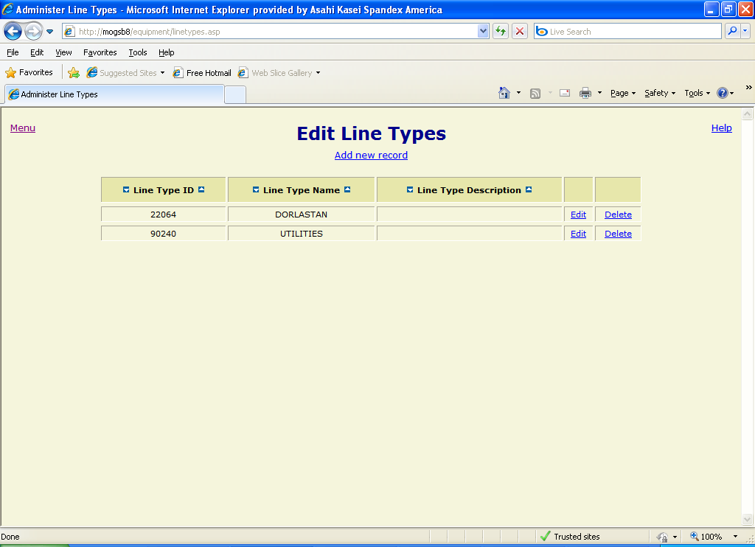
Figure 28

Edit Line Types
Updates the line_types table. This data is used on the “Lines” administrative form to specify the functional type of the line. The table consists of the following fields:
- line_type_id – Unique identifier, automatically assigned.
- line_type_name – The name of the line type (required, must be unique).
- line_type_desc – Description of the line type.

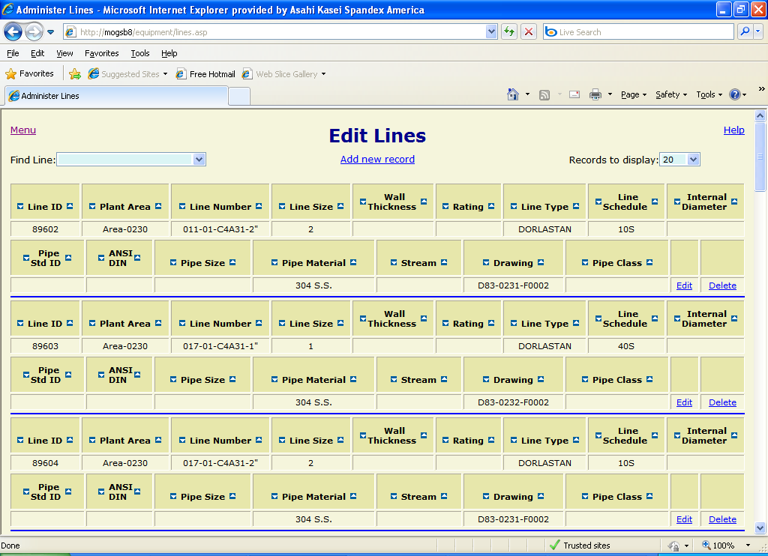
Figure 29

Edit Lines
Updates the process_lines table. This data is used on instrument spec forms to specify the process line to which the instrument is associated. Corresponding data on the form is automatically displayed when a specific line is selected. The table consists of the following fields:
- line_id – Unique identifier, automatically assigned.
- plant_area_id – The plant area to which the line applies, id number from the plant_areas table.
- line_num – The name assigned to the line (required, must be unique).
- line_size – The nominal diameter of the line in inches.
- wall_thick – The wall thickness of the line in inches.
- rtg – The line rating.
- line_type_id – The functional type of the line, id number from the line_types table.
- line_sched – The line schedule number to specify the weight of the pipe based on ANSI/ASME standards.
- line_internal_dia – The internal diameter of the line in inches.
- pipe_std_id – The piping standard, id number from the pipe_standard table.
- ansi_din – The ANSI/DIN fitting standard for the line.
- pipe_size – The nominal diameter of the pipe in inches.
- pipe_orif_mat_id – The piping material, id number from the pipe_materials table.
- stream_num – The process stream for which the line is used.
- dwg_id – The drawing that applies to the line, id number from the drawings table.
- pipe_class_id – The pipe classification, id number from the pipe_classes table.

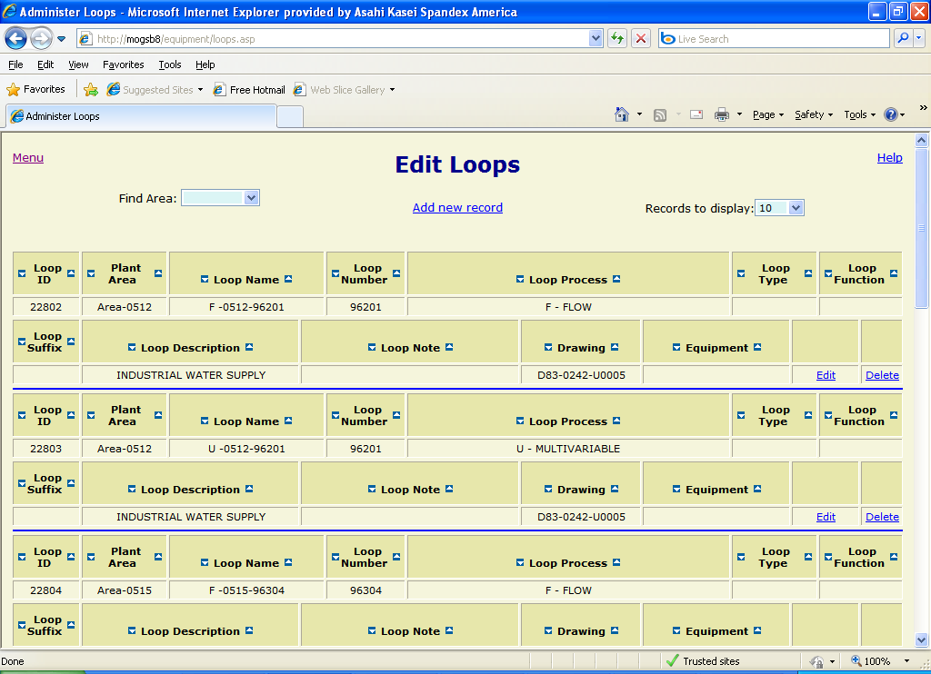
Figure 30

Edit Loops
Updates the loops table. This data is used when adding a new instrument specification or searching for an existing one to specify the process loop to which the instrument belongs. The table consists of the following fields:
- loop_id – Unique identifier, automatically assigned.
- plant_area_id – The plant area to which the loop is assigned, id number from the plant_areas table.
- loop_name – The name of the process loop (required, must be unique).
- loop_num – The loop number (i.e. the last 5 digits of the loop name).
- loop_proc_id – The loop process variable type (e.g. flow, level, etc.), id number from the loop_process table.
- loop_type_id – The loop type (e.g. DCS, PLC, electrical, etc.), id number from the loop_types table.
- loop_func_id – The loop function, id number from the loop_functions table.
- loop_suff – The loop name suffix (e.g. A, B, etc.).
- loop_desc – Description of the loop.
- loop_note – Note about the loop.
- dwg_id – The drawing that applies to the loop, id number from the drawings table.
- loop_equip_id – The equipment to which the loop applies, id number from the equipment table.

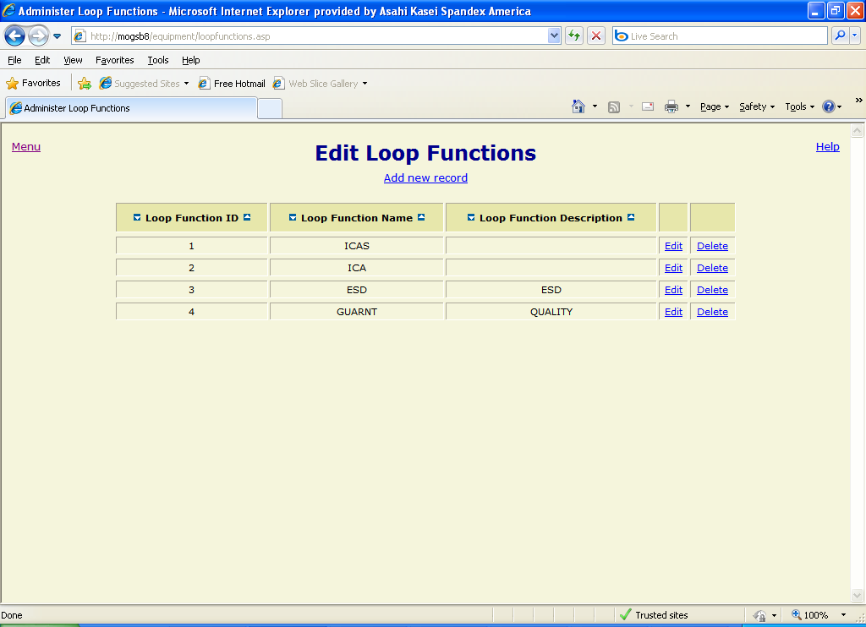
Figure 31

Edit Loop Functions
Updates the loop_functions table. This data is used on the “Loops” administrative form to specify the function for the loop. The table consists of the following fields:
- loop_func_id – Unique identifier, automatically assigned.
- loop_func_name – The name of the loop function (required, must be unique).
- loop_func_desc – Description of the loop function.

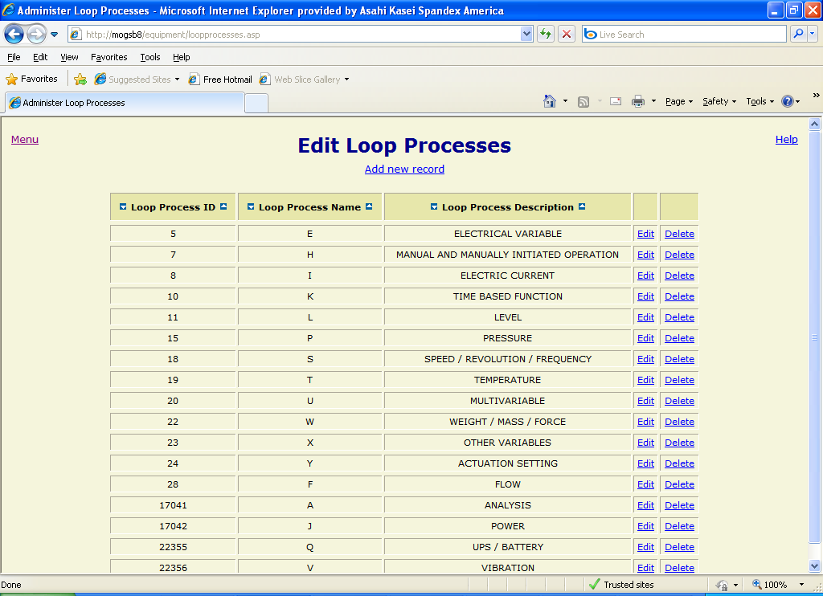
Figure 32

Edit Loop Processes
Updates the loop_processes table. This data is used on the “Loops” administrative form to specify the process variable type for the loop. The table consists of the following fields:
- loop_proc_id – Unique identifier, automatically assigned.
- loop_proc_name – The name of the loop process (required, must be unique).
- loop_proc_desc – Description of the loop process.

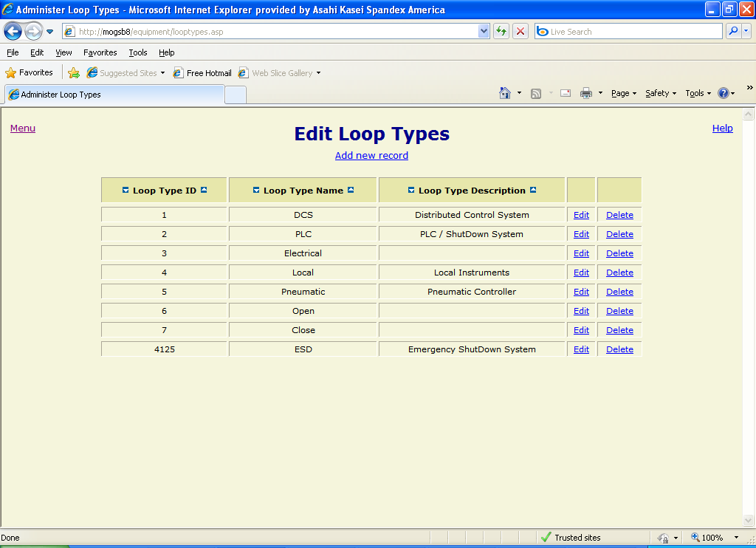
Figure 33

Edit Loop Types
Updates the loop_types table. This data is used on the “Loops” administrative form to specify the type of loop. The table consists of the following fields:
- loop_type_id – Unique identifier, automatically assigned.
- loop_type_name – The name of the loop type (required, must be unique).
- loop_type_desc – Description of the loop type.

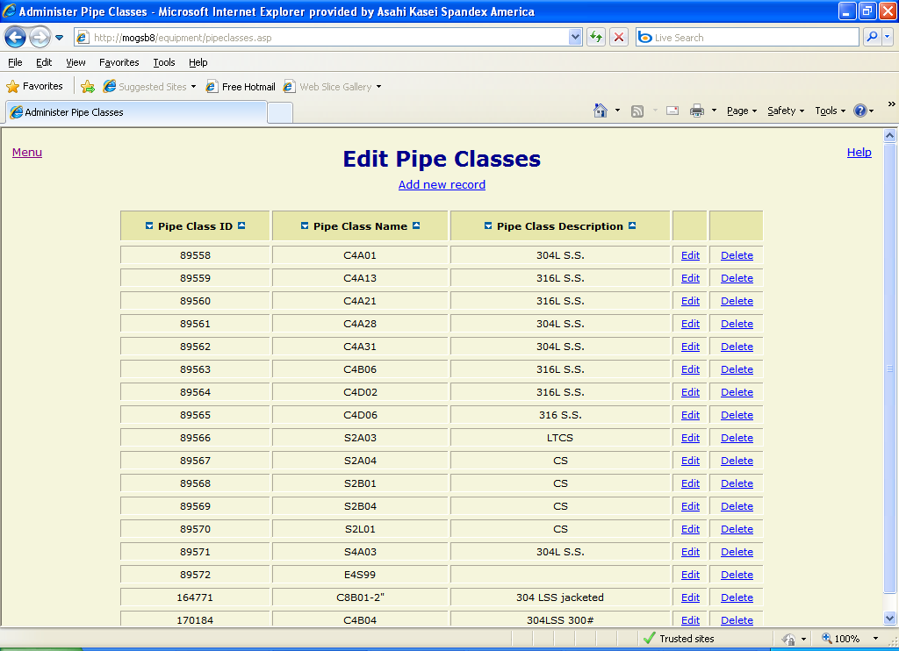
Figure 34

Edit Pipe Classes
Updates the pipe_classes table. This data is used on the “Lines” form to specify the pipe classification for the process line. The table consists of the following fields:
- pipe_class_id – Unique identifier, automatically assigned.
- pipe_class_name – The name of the pipe classification (required, must be unique).
- pipe_class_desc – Description of the pipe classification.

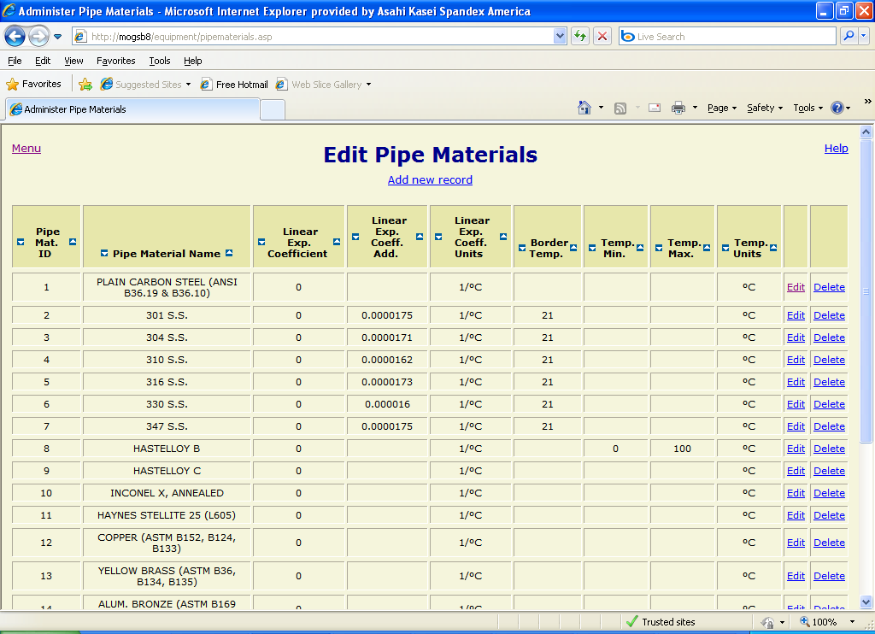
Figure 35

Edit Pipe Materials
Updates the pipe_materials table. This data is used on the “Lines” administrative form to specify the pipe material for the process line. The table consists of the following fields:
- pipe_mat_id – Unique identifier, automatically assigned.
- pipe_mat_name – The name of the pipe material (required, must be unique).
- linear_exp_coef – The linear expansion coefficient for the material based on the units found in the field linear_exp_coef_uid.
- linear_exp_coef_add – Additional linear expansion coefficient for the material based on the units found in the field linear_exp_coef_uid.
- linear_exp_coef_uid – The unit of measure for the linear expansion coefficient.
- border_temp – The border temperature of the pipe material based on the units specified in the temp_uid field.
- temp_min – The minimum temperature of the pipe material based on the units specified in the temp_uid field.
- temp_max – The maximum temperature of the pipe material based on the units specified in the temp_uid field.
- temp_uid – The unit of measure for the temperature fields.

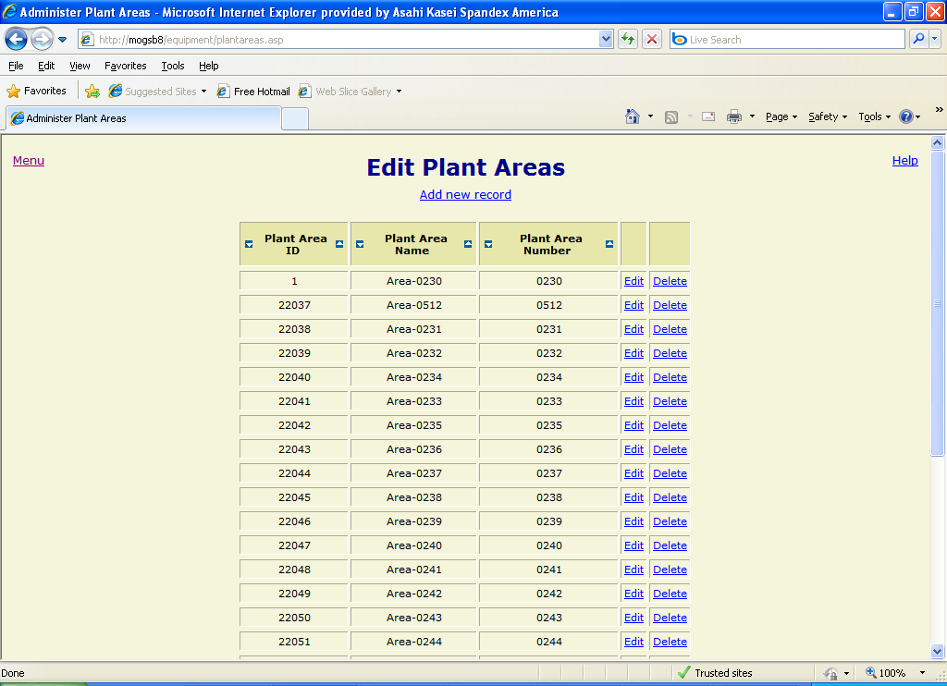
Figure 36

Edit Plant Areas
Updates the plant_areas table. This data is used on instrument spec forms and several administrative forms to specify the plant area to which an object is assigned. The table consists of the following fields:
- plant_area_id – Unique identifier, automatically assigned.
- plant_area_name – The name of the plant area (required, must be unique).
- plant_area_num – The plant area number (i.e. the last 4 digits of the plant area name).

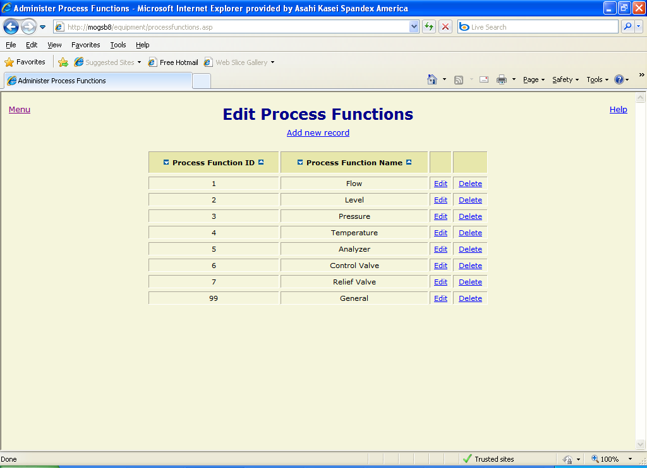
Figure 37

Edit Process Functions
Updates the process_functions table. This data is used on the “Instrument Function Types” administrative form and when searching for an instrument specification. The table consists of the following fields:
- proc_func_id – Unique identifier, automatically assigned.
- proc_func_name – The name of the process function (required, must be unique).

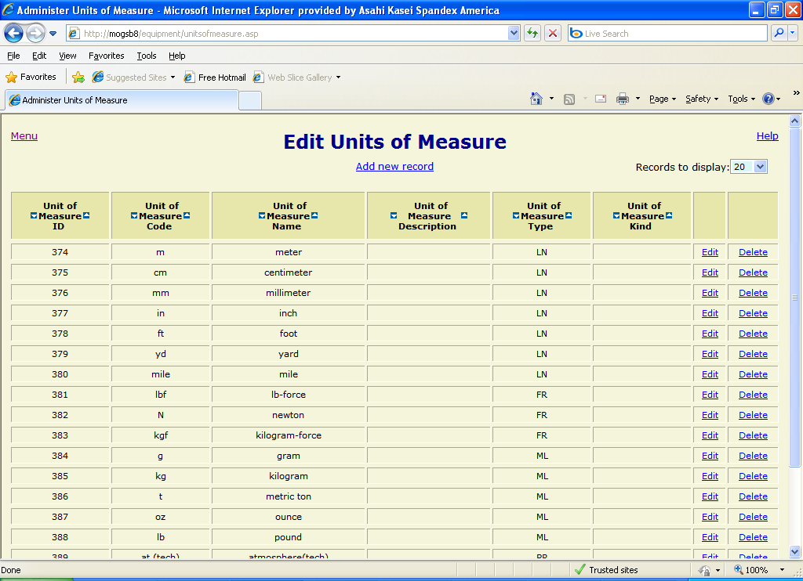
Figure 38

Edit Units of Measure
Updates the units_of_measure table. This data is used on instrument spec forms to specify the unit of measure for process parameters. The table consists of the following fields:
- uom_id – Unique identifier, automatically assigned.
- uom_code – The short form of the unit of measure name to be displayed in dropdown lists on spec forms (required).
- uom_name – The name of the unit of measure (required).
- uom_desc – Description of the unit of measure.
- uom_type – The unit of measure type from the unit_of_measure_types table. This field is used to restrict values in dropdown lists to units of a particular type (e.g. flow or pressure).
- uom_kind – The unit of measure kind.

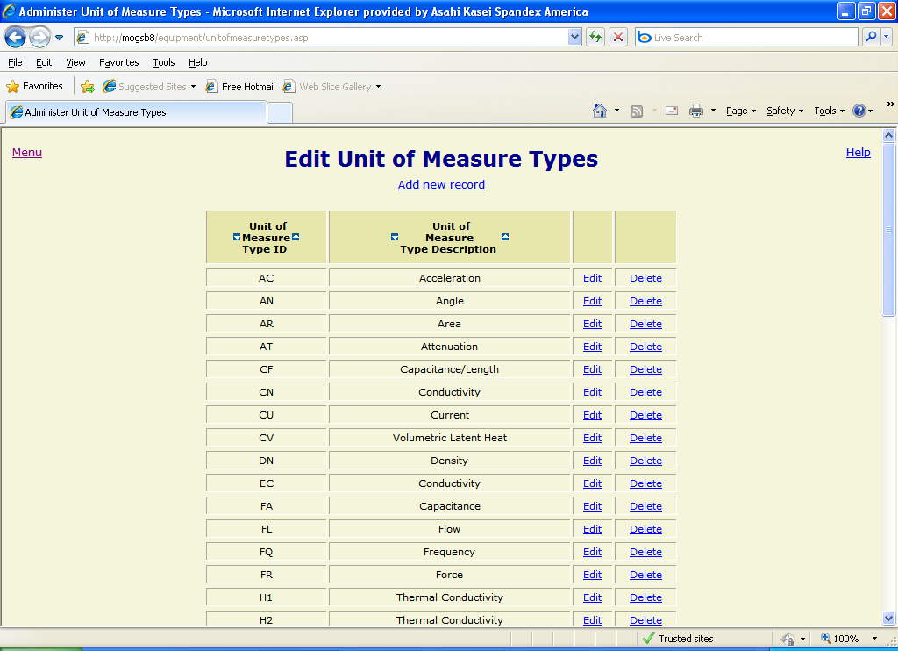
Figure 39

Edit Unit of Measure Types
Updates the unit_of_measure_types table. This data is used on the “Units of Measure” administrative form to specify the type of unit of measure. The table consists of the following fields:
- uom_type_id – Unique identifier (required, 2 characters, must be unique).
- uom_type_desc – Description of the unit of measure type (required).

Security
The Instrument Spec Database application uses integrated authentication and form-level security. This means that users are automatically identified by the system based on their operating system logon and their permissions are examined for each web page that they attempt to access.

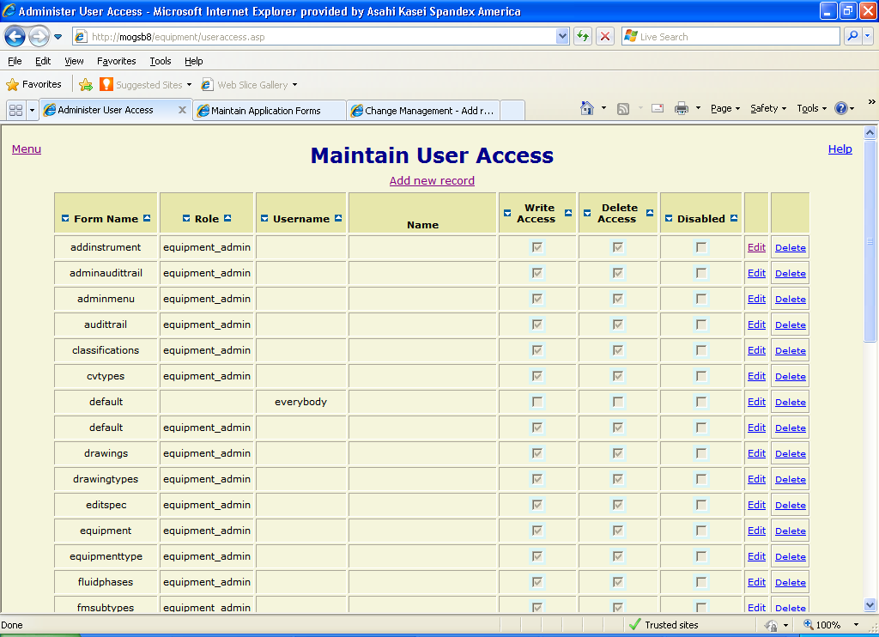
Figure 40

User Access
The “Maintain User Access” form (Figure 40) allows users with the appropriate permission level to assign user or role privileges for each web form. These privileges dictate if a user or role can view a particular form and, if so, the way that it is displayed. The following list describes the rules governing permissions on a given form:
- If no records have been entered for the form, all users and roles have all privileges.
- If a record for the user “everybody” has been entered for the form, all users and roles have the privilege level specified in that record as a minimum.
- If there is at least one record for the form and there is no record for the user ”everybody” and there is no record for a specific user or a role that the user is a member of, that user has no privilege on the form and he will receive a denial message (Figure 41) if he/she tries to access the form.
- If a user has a record entered for the form, his/her privileges on the form are based on the following columns:
  - Write Access – a check mark in this column allows the user to edit and add records in the form. This is accomplished by displaying the “Edit” and “Add new record” links in the form.
  - Delete Access – a check mark in this column provides the user with the capabilities of “write” access and, in addition, allows him/her to delete records from the form. This is accomplished by displaying the “Delete” link in the form.
  - Disabled – a check mark in this column indicates that the user has no access on the form, regardless of the values in the other columns.
  - If none of the columns are checked, the user has read-only privilege on the form and the “Edit”, “Delete” and “Add new record” links will not be displayed.
- If a role has a record entered for a given form, all members of that role (see Role Members below) have the privileges assigned to the role as described above.

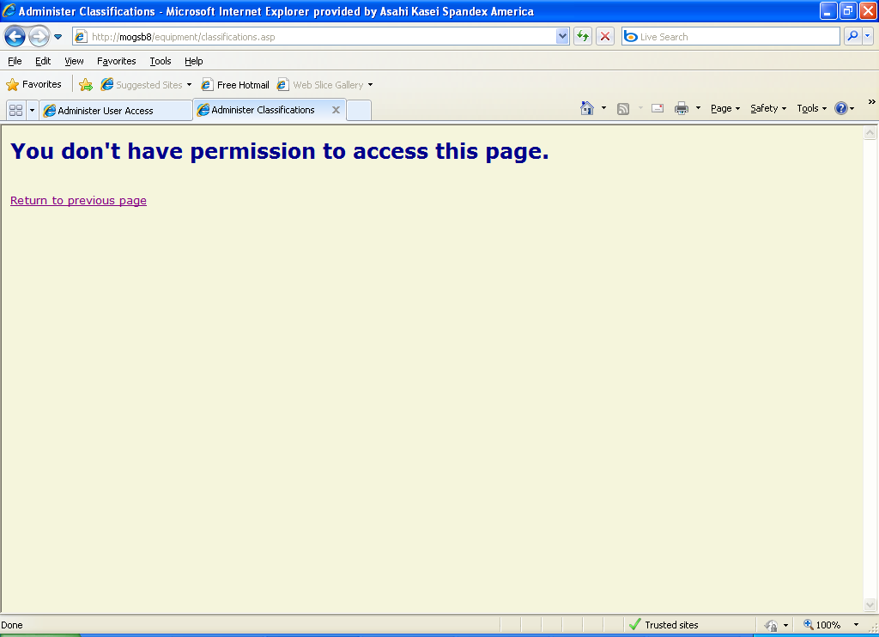
Figure 41

Sorting records
Each column header on the “Maintain User Access” form has links to allow the user to sort the table records based on the data contained in that column. Clicking on the icon sorts the records in descending order (e.g. 5, 4, 3, 2, 1), while clicking on the icon sorts the records in ascending order (e.g. 1, 2, 3, 4, 5).

Adding a new record
To insert a new record into the “Maintain User Access” form, click on the “Add new record” link below the page title. A blank record will be opened in the first row of the table with dropdown lists or checkboxes displayed for modifiable fields. Enter the desired data in the fields and click the “Submit” button to insert the record. The page will refresh with the new record in its appropriate position based on the specified sort order. To cancel the insertion of a record before submitting, click the “Cancel” link or use your browser’s “back” button.

Editing a record
To edit an existing record, click on the “Edit” link to the right of the record to be modified. The record will be displayed with modifiable fields as dropdown lists or check boxes. After changing the field values as desired, click the “Submit” button to the right of the record to update the database. To cancel the update before submitting, use the “back” button on your browser to return to the previous screen.

Deleting a record
To delete an existing record, click the “Delete” link to the right of the record to be deleted. A confirmation message will be displayed. Click the “OK” button to complete the deletion or the “Cancel” button to stop it.

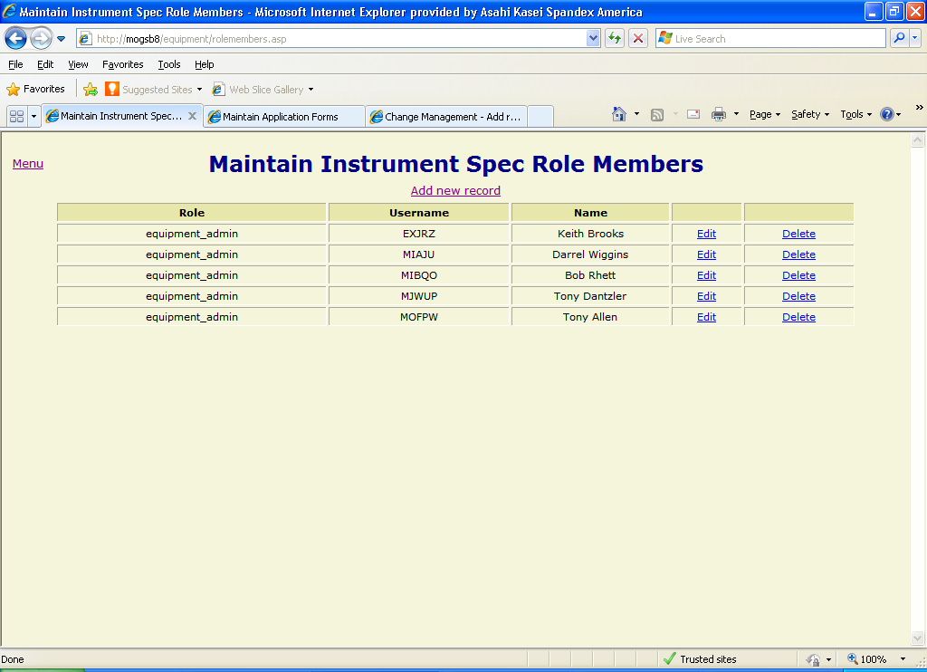
Figure 42

Role Members
The “Maintain Instrument Spec Role Members” form (Figure 42) allows users with the appropriate permission level to assign users to Instrument Spec security roles. The roles are assigned privileges for each form on the “Maintain User Access” form (see User Access above) and a member of a given role inherits that role’s permissions.

Adding a new record
To insert a new record into the “Maintain Instrument Spec Role Members” form, click on the “Add new record” link below the page title. A blank record will be opened in the first row of the table with dropdown lists displayed for modifiable fields. Enter the desired data in the fields and click the “Submit” button to insert the record. The page will refresh with the new record in its appropriate position based on the specified sort order. To cancel the insertion of a record before submitting, click the “Cancel” link or use your browser’s “back” button.

Editing a record
To edit an existing record, click on the “Edit” link to the right of the record to be modified. The record will be displayed with modifiable fields as dropdown lists. After changing the field values as desired, click the “Submit” button to the right of the record to update the database. To cancel the update before submitting, use the “back” button on your browser to return to the previous screen.

Deleting a record
To delete an existing record, click the “Delete” link to the right of the record to be deleted. A confirmation message will be displayed. Click the “OK” button to complete the deletion or the “Cancel” button to stop it.

